
CASA of Arizona
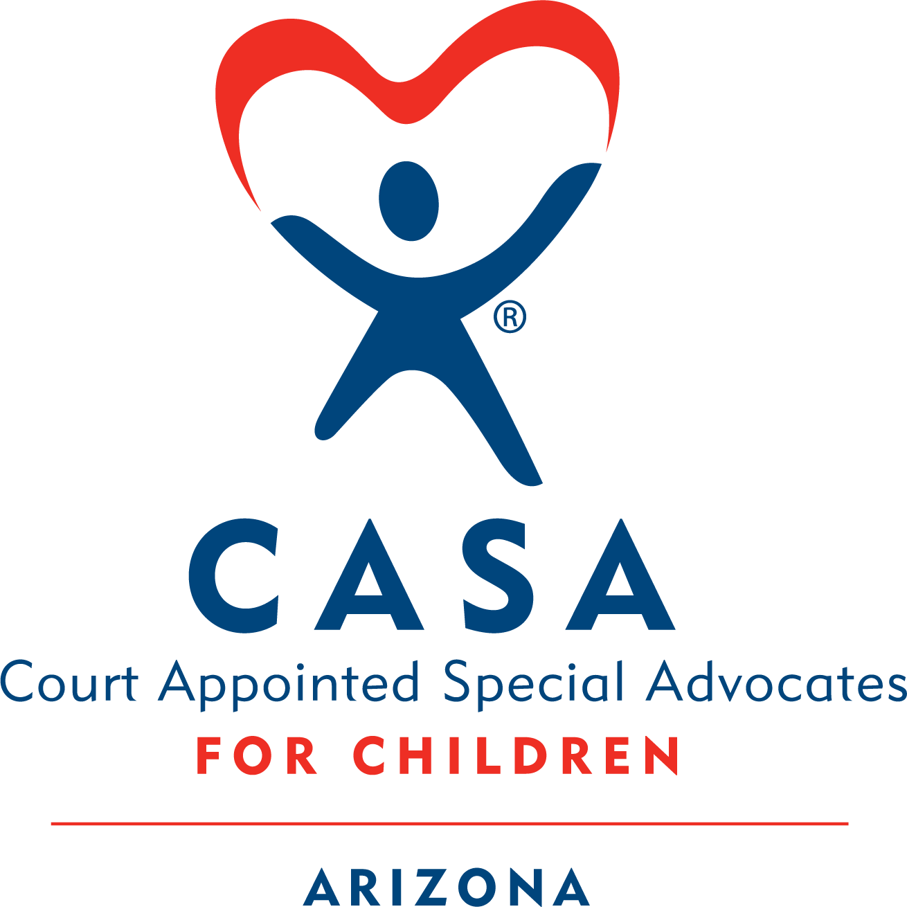
Virtual
Module 2 Homework
Contents
❖ Activity 2.1 Rosa Case 2
❖ Activity 2.2 Who Participates in a Case 3
❖ Activity 2.3 Resources vs. Deficits 5
❖ Activity 2.4 Exploring the Impact of Stress 7
❖ Activity 2.5 Recognizing Abuse & Neglect 9
❖ Activity 2.6 Conditions That May Lead to Abuse and Neglect 9
❖ Activity 2.7 The Best Interest Principle and MSL 12
❖ Activity 2.8 Child Development 14
❖ Activity 2.9 Attachment 15
❖ Activity 2.10 Signing up for LMS: 18

Activity 2.1 Rosa Case

Rosa Case: Continuing the Story
In your Welcome Module, you read the Dependency Petition for the Rosa Case and practiced writing the Brief History section of a court report.
Now, you’ll continue following the Rosa family’s journey through the dependency process.
For this session, you’ll read:
- DCS’s first report to the court after removal
(This report is prepared ahead of the Preliminary Protective Hearing and/or Initial Dependency Hearing)
- CASA contact logs
(Written by you, the CASA, summarizing contact with key individuals in the case)
In Module 2’s live session, we’ll walk through the Arizona Dependency Process and explain these hearing types in more detail.
Please note that you will participate in activities related to the Rosa Case at each live session, so it is important that you are familiar with the materials. It may be helpful for you to take notes on the information you are gathering.
To begin: Open the PDF below to read the documents for the Rosa case.
📂 How to open the document:
- Double-click the PDF icon labeled “Module 2 Rosa Documents”
- If it doesn’t open, right-click the icon, choose ‘Object’ from the menu, then click ‘Open’
- If it still isn’t working, click on this link Homework to access it through the website.

Activity 2.2 Who Participates in a Case

Who Participates in a Case?

Who’s Involved in a Dependency Case?

The Child
- The case is in court because of alleged abuse or neglect.
- The child needs a safe, stable, and supportive home.
- Court intervention should be timely and focused on services that meet the child’s needs—like education, health, cultural identity, and permanency.

The Judge
- Oversees the case and ensures the child’s safety and legal rights.
- Decides if abuse or neglect occurred and what services are needed.
- Determines if there is a continued safety issue for the child that necessitates continued out-of-home placement if the child has been removed from the home.
- Approves the permanency goal, hears testimony, and may terminate parental rights or close the case when appropriate.

The CASA Volunteer
- Gathers information and identifies the child’s needs.
- Collaborates with the team towards the shared goal of permanency.
- Recommends services and supports (advocates).
- Monitors the case and advocates for the child’s best interest.
- Is a voice for the child’s expressed wishes.

Attorneys
For the Child
- Helps the child understand the legal process.
- Shares the child’s needs and wishes with the court.
- Files legal documents on the child’s behalf.
For the Parent/Caretaker
- Represents the parent’s wishes and legal rights.
- Advises them on legal matters and files documents.
For DCS (Assistant Attorney General)
- Represents DCS in court and protects it from liability.
- Advises DCS of its legal responsibility and files legal documents.

Parents/Caretakers
- Named in the petition due to concerns about abuse, neglect, or unmet needs.
- Must meet the Conditions for Return (CFRs) and the MSL standard in order to reunify with their child.

Department of Child Safety (DCS)
There are typically several Department of Child Safety case managers involved at different points in each case. The assigned DCS case manager is the legal guardian for the child during the dependency case. The court gives the DCS case manager discretion and authority to make decisions throughout the case.
- Hotline Worker: Takes initial reports of abuse and neglect and prioritizes response.
- Investigator: Assesses safety through the Family Functioning Assessment, investigates allegations, and initiates court involvement if needed.
- Ongoing Case Manager: Manages the case, supports reunification, and coordinates services.
Depending on the region of the state, the case may transfer to a specialized case manager at certain points in the dependency process.
- Adoptions Case Manager: Provides services and support to help finalize adoptions after parental rights are severed.
- Young Adult Program Manager: Supports youth 16+ with transition to adulthood planning who have an APPLA case plan goal.
- ICWA Case Manager: Handles cases involving Native American children under the Indian Child Welfare Act.

Tribal Representative: Attorney and/or Social Worker (if applicable)
- Ensures ICWA standards are upheld and protects the tribe’s interest in the case.
- Advocates for culturally appropriate services.
- May request the tribe take jurisdiction of the case.

Foster Care Review Board (FCRB)
- Reviews case progress and makes recommendations to the court.
- Responsible to review all cases of out-of-home care.

Service Providers
- Deliver treatment and support services to the child and/or parents.
- Provide observations and recommendations to the team.

Placement Providers
- Provide daily care for the child.
- Help meet the child’s physical, emotional, educational, and cultural needs.
- May include:
- Relatives or kinship caregivers
- Licensed foster homes
- Group homes
- Specialized care (e.g., therapeutic foster care, inpatient facilities)

Activity 2.3 Resources vs. Deficits

Seeing Strengths: The Lens You Use Matters
You’ve probably heard the question: Is the glass half full or half empty?
As a CASA volunteer, you face a similar choice when working with families—do you focus on what’s working, or what’s missing?
Two Ways to View a Family:
- A resource lens helps you see strengths, potential, and opportunities.
- A deficit lens focuses on problems, limitations, and what’s going wrong.
All families have strengths. The lens you choose shapes how you interact with families—and how you collaborate with others on the case.

Resources vs. Deficits Comparison Table
If I look through a RESOURCES lens, I am likely to… | If I look through a DEFICITS lens, I am likely to…
Look for positive aspects | Look for negative aspects
Empower families | Take control or rescue
Create options | Give ultimatums or advice
Listen | Tell
Focus on strengths | Focus on problems
Put the responsibility on the family | See the family as incapable
Acknowledge progress | Wait for the finished product
See the family as expert | See service providers as experts
See the family invested in change | Impose change or limits
Help identify resources | Expect inaction or failure
Avoid labeling | Label
Inspire with hope | Deflate the family’s hope

Why This Matters
Using a strengths-based approach means recognizing and building on the resources already present in a family—including extended family and community connections. For example:
- You might identify a relative who can offer a safe home.
- You could help a parent reconnect with a past support system.
- You may uncover adults who’ve played a positive role in the child’s life.
This approach opens more doors, builds trust, and supports lasting change.
Try Asking These Questions:
- How has this family solved problems in the past?
- What court-ordered steps have they already completed?
- Are there extended family or close friends who could help?
- How are they coping with their current situation?
Cultural Considerations: Understanding Family Strengths
Strengths don’t look the same in every family.
Family structures, roles, customs, communication styles, and parenting approaches are shaped by cultural norms and community values.
Examples:
- In many Western cultures, it’s common for children to sleep in their own bed or room.
In other cultures, shared sleeping arrangements are seen as nurturing and protective.
- Similarly, while the nuclear family is often idealized in the U.S., many communities rely on extended family, faith-based networks, or close friends to help raise children.

Rethinking Resources
Families from different cultures and socioeconomic backgrounds may rely on non-material resources to cope with challenges. These strengths may not be immediately visible—but they’re just as powerful.
Here are some examples:
- Mental ability – Using knowledge and problem-solving skills
- Emotional strength – Staying resilient during tough times
- Spiritual grounding – Finding meaning and purpose
- Physical health – Supporting independence and self-care
- Cultural heritage – Providing values, traditions, and identity
- Support systems – Offering help in times of need (e.g., childcare, financial aid, advice)
- Healthy relationships – Nurturing and protective connections
- Role models – Guiding with lived experience and encouragement
Recognizing these diverse strengths helps you approach families with respect, empathy, and a broader understanding of what support can look like.
Refer to worksheet and answer the question.

Activity 2.4 Exploring the Impact of Stress
Understanding Family Stress & Building Resilience
🔹 Part 1: Recognizing the Weight of Stress
Every family has strengths—and every family faces challenges.
But when challenges pile up — the family moves, a parent is laid off, childcare arrangements fall through, a new stepfamily comes into being, the car breaks down, a child becomes ill, the rent goes up and so on – stress can turn into crisis.
As a CASA volunteer, you’ll work with families who are often overwhelmed, isolated from support, and under intense pressure. Their involvement in the child welfare system adds even more stress, especially when their parental rights feel threatened.
Some families adapt and grow through crisis. Others struggle, and that stress can interfere with their ability to meet their children’s needs—sometimes leading to patterns of abuse or neglect.
Part 2: Watch & Reflect
Watch this 5-minute video:
🎥 How to open the video:
- Click the link below labeled Building Adult Capabilities to Improve Child Outcomes (YouTube Video).
- If it doesn’t open right away, try this:
    - Hold down the “Ctrl” key on your keyboard.
    - While holding it, click the link with your mouse.
Still not working?
No problem! You can also find the video link on the homework website. Homework

Building Adult Capabilities to Improve Child Outcomes (YouTube Video)

Refer to worksheet and answer the question.

Part 3: Assessing Stress
Complete the Stress Level Assessment. This tool will help you better understand how stress builds—and how it feels to be in crisis.
🌎How to open the link
- Click the link below labeled Test Your Stress, Be Mindful.
- If it doesn’t open right away, try this:
    - Hold down the “Ctrl” key on your keyboard.
    - While holding it, click the link with your mouse.
  - If it still isn’t working, click on this link Homework to access it through the website.

Test Your Stress | Be Mindful

Refer to worksheet and answer the questions.

Activity 2.5 Recognizing Abuse & Neglect

Recognizing Abuse and Neglect
As a CASA volunteer, your role is not to decide whether a child has been abused or neglected—that’s the court’s responsibility.
However, it’s essential that you can recognize potential signs of abuse or neglect so you can advocate for the child’s safety and well-being.

Keep in mind:
- Some signs may stem from trauma or stress, not necessarily abuse.
- Regardless of the cause, these signs indicate that a child may need help and support.

In Dependency cases, the legal definitions of abuse and neglect are outlined in Arizona law.

Click the link below to review the Arizona Revised Statute on child abuse and neglect.

📂 How to open the document:
- Double-click the link below labeled “Abuse & Neglect Statute”
- If it doesn’t open right away, try this:
    - Hold down the “Ctrl” key on your keyboard.
    - While holding it, click the link with your mouse.
- If that doesn’t open it, try right-clicking the link and selecting “Open Hyperlink”
- If it still isn’t working, click on this link Homework to access it through the website.

Abuse & Neglect Statute

Activity 2.6 Conditions That May Lead to Abuse and Neglect
Understanding Risk Factors for Abuse and Neglect
There’s rarely a single cause of child abuse or neglect. Instead, it’s often the result of multiple, overlapping stressors—related to the child, the caregiver, the family, or the environment. These risk factors don’t always lead to abuse, but they can increase the likelihood, especially when families lack support.
Child-Related Risk Factors
- Young age: Half of abused children are under 3; most fatalities occur before age 1.
- High needs: Children with disabilities or complex medical needs may increase caregiver stress.
- Temperament mismatch: A child’s behavior may clash with a parent’s expectations or coping style.
- Attachment issues: Separation during early development or limited bonding can affect relationships.
- Unwanted or symbolic child: A child may be resented if they remind a parent of a painful relationship or were not planned.
- Premature birth or early illness: This can lead to financial stress, inability to bond and parental feelings of guilt, failure or inadequacy.
Parent/Caregiver Risk Factors
- Low self-esteem: This may lead to neglecting themselves or seeing themselves as not worthy.
- Abuse as a child: Parents may repeat their own childhood experience if no healing or intervention occurred and no new or adaptive skills were learned.
- Depression or other untreated mental health conditions: Caregivers experiencing mental health issues may struggle to meet their children’s needs, and their symptoms can sometimes be misunderstood by themselves or others as a sign of being “uncaring” or “withdrawn.”
- Substance use: Substance use—whether alcohol or drugs—is often an attempt to cope with stress or overwhelming circumstances. While it may provide short‑term relief, it typically leads to additional challenges that can further affect a caregiver’s stability and functioning.
- Lack of knowledge about child development: A parent may have expectations that are not age-appropriate.
- Social isolation: Abusive and neglectful families may tend to avoid community contact and have few family ties to provide support.
- Cognitive delays: These may affect decision-making or parenting capacity.
Social & Situational Risk Factors
- Cruelty in Child-Rearing Practices: Violence or harsh discipline may be normalized in some families, cultures, or communities.
- Devaluation of children or dependence on control-based parenting
- Systemic inequalities in healthcare, education, and justice systems: This increases stress and impacts available resources for families.
- Lack of support systems: The lack of extended family or community support can increase the stress and decrease the coping resources in a family.
Family Risk Factors
- Domestic violence: Children may be harmed directly or indirectly in violent homes.
- Blended families: Non-biological caregivers may pose increased risk, especially during transitions and times of higher stress.
- Single parenting: This can bring financial strain and limited support.
- Teen parents: They may lack the maturity or resources to meet a child’s needs.
- Scapegoating: One child may be unfairly blamed or targeted within the family.
Triggering Situations
Even when risk factors are present, abuse often occurs during moments of acute stress. These triggers can escalate quickly or build over time:
- A baby won’t stop crying
- A parent is overwhelmed by toilet training
- Job loss or eviction
- A serious illness or accident
- Stopping a needed medication
Recognizing risk factors doesn’t mean making assumptions—it means being alert to the context in which families are struggling and advocating for the support and services they need to keep children safe.
Refer to worksheet and answer the question.

Activity 2.7 The Best Interest Principle and MSL

Part 1:
Courts make a variety of decisions that affect children, including placement and custody determinations, safety and permanency planning, and proceedings for termination of parental rights. Whenever a court makes such a determination, judges must weigh whether the decision will be in the "best interests" of the child.
Best Interest Definition
Although there is no standard definition of "best interests of the child," the term generally refers to the deliberation that courts undertake when deciding what type of services, actions, and orders will best serve a child as well as who is best suited to take care of a child. "Best interests" determinations are generally made by considering a number of factors related to the child's circumstances and the parent or caregiver's circumstances and capacity to parent, with the child's ultimate safety and well-being the paramount concern.
Best Interest Factors
The importance of family integrity and preference for avoiding removal of the child from his/her home
- The health, safety, and/or protection of the child
- The importance of timely permanency decisions
- The assurance that a child removed from his/her home will be given care, treatment, and guidance that will assist the child in developing into a self-sufficient adult
- The emotional ties and relationships between the child and his or her parents, siblings, family and household members, or other caregivers
- The capacity of the parents to provide a safe home and adequate food, clothing, and medical care
Courts are provided with a set of goals to "facilitate the care, protection, and discipline of children" who come within their jurisdiction. This should include steps to maintain Tribal relationships and preserve the child's unique Tribal culture and values. When out-of-home care is needed, the child must be placed, whenever possible, with a family that can help the child maintain these connections, as required by the Federal Indian Child Welfare Act (P.L. 95-608).

Other Considerations
Other factors that courts commonly take into consideration in making best interests determinations include the following:
- Federal and/or State constitution protections.
- The importance of maintaining sibling and other close family bonds.
- The child's wishes.
CITATION:
Child Welfare Information Gateway. (2020). Determining the best interests of the child. Washington, DC: U.S. Department of Health and Human Services, Administration for Children and Families, Children's Bureau.

Indian Child Welfare Act (ICWA)
In cases where the Indian Child Welfare Act (ICWA) applies, the law presumes that it is always in the best interest of an Indian child to have the tribe determine what is best for the child’s future.
*This curriculum uses the terms “Indian child” and “Indian custodian” in accordance with the legal definitions set out in the Indian Child Welfare Act.

Reminder for CASA Volunteers:
- Your job is to identify and advocate for unmet needs—especially those that affect a child’s safety, stability, and development.
- A child’s needs will vary based on their age, development, relationships, and life experiences.
- Meeting basic needs lays the foundation for emotional and social growth.

Minimum Sufficient Level of Care
Minimum Sufficient Level of Care is the legal standard used to determine if children can safely remain in their homes and/or return to their homes. This is the standard the court uses in making decisions regarding out of home care. Research has shown that children do best when they can remain with their family or return to their family quickly. Federal law and the MSL standard allows for more families to stay together.

Open the MSL (Activity 2.7) PDF icon to read about MSL.
📂 How to open the document:
- Double-click the PDF icon labeled “MSL”
- If it doesn’t open, right-click the icon, choose ‘Object’ from the menu, then click ‘Open’
- If it still isn’t working, click on this link Homework to access it through the website.
Refer to worksheet and answer the questions.

Optional:
Want to learn more about the MSL standard? Click the link to listen to a podcast that discusses the CASA role as it relates to the MSL standard. (You might have to press and hold “Ctrl” on your keyboard while clicking on the link with your mouse to open it.)
CASA on the Go Podcast (22min)

Activity 2.8 Child Development

Key Insights on Child Development
The Center on the Developing Child at Harvard University highlights eight important things to remember about child development. These insights are especially important for CASA volunteers to understand as you advocate for a child’s well-being:
- Stress affects even the youngest children—infants and toddlers are deeply impacted by instability in their caregiving environment.
- Development is interactive—genes matter, but relationships and experiences shape outcomes.
- Children need strong attachments—while parents are primary, other caring adults also play a vital role.
- Early years are critical—the brain develops rapidly in the first three years, but opportunities for growth and development continues well beyond that.
- Severe neglect can be as harmful as abuse—and in some cases, even more damaging to development.
- Adversity doesn’t define destiny—Young children who have been exposed to adversity or violence do not necessarily develop long term problems that impact functioning.
- Safety alone isn’t enough—Simply removing a child from a dangerous environment will not automatically reverse the negative impacts of that experience.
- Resilience is built through relationships—children thrive when they have consistent, supportive connections.

Activity 2.9 Attachment

Understanding Attachment in Children: Why it matters—and how it shapes everything.

What Is Attachment?
Attachment is the deep emotional bond that forms between a baby and their caregiver. It doesn’t happen all at once—it grows through consistent, responsive care. (Ogunye, 2023)

This connection is built through attunement—noticing and responding to a baby’s cues, even before they cry. It’s how babies learn: “I matter. I’m safe. I’m seen.” According to research (Ogunye, 2023):
- By 1 month, infants know what characteristics (voice, touch) go with each caregiver.
- By 3 months, infants can even show preferences for certain voices.
- By 4 months, infants begin to form expectations of what their caregivers will be like-will they be gentle, will they be attentive, or will they be upsetting
Even in neglectful or abusive environments, children still form attachments. But the quality of that attachment depends on how caregivers respond when the child seeks comfort or safety. The first relationship between child and caregiver establishes the foundation for relationships throughout the lifespan(Beltre & Mendez, 2023).

Brain Development & Attachment
The human brain—our body’s command center—is the only organ that is not fully developed at birth. A newborn’s brain is about one‑fourth the size of an adult brain, but it grows rapidly. It doubles in size during the first year and reaches about 80% of adult size by age 3. By age 5, it is nearly fully grown at about 90% of adult size. During these early years, the brain forms at least one million new neural connections every second, a rate unmatched at any other point in life (First Things First, n.d.).
From birth, a child’s everyday experiences shape how these brain connections form (First Things First, n.d.). Both positive and negative experiences influence this development.
The Harvard Center on the Developing Child notes that sensitive caregiving—responding promptly and appropriately to a child’s signals and needs—supports the development of secure attachment.
Infants who form a secure attachment with a caregiver tend to show positive outcomes in many areas, including:
- Trust
- Learning
- Thinking
- Coping
- Developing a conscience
- Regulating emotions
- Becoming self‑reliant
- Building future relationships
(Ogunye, 2023)
According to the Child Welfare Information Gateway, frequent or intense stress can cause a child’s brain to become overly sensitive to perceived threats. As a result, the child may react impulsively, aggressively, or in other maladaptive ways with very little provocation. For example, a child who has experienced maltreatment may become distressed by a caring touch, such as a hug or a gentle pat on the back, or may react with fear to a caregiver’s mildly frustrated or even neutral facial expression. Their threat‑detection system becomes hyperalert, causing them to interpret safe situations as dangerous.
Signs of Attachment Issues
Attachment challenges can range from mild to severe. About 35% of infants show signs of insecure attachment. (Smith, Robinson, Segal & Reid, 2023)

In infants (12–20 months) (Smith, Robinson, Segal & Reid, 2023):
- Seem indifferent to the caregiver’s presence or absence
- Cry inconsolably, even when comforted
- Show fear or anger when you return

In school-age children(Smith, Robinson, Segal & Reid, 2023):
- Withdraw from peers or group activities
- Act out to gain attention
- Bully others or defy adults
- Hypervigilant or easily stressed
- Seem overly dependent or emotionally volatile

In teens (Monaco, Schoeps & Montoya-Castilla, 2019):
- Struggle with impulse control
- Behavioral issues
- Engage in risky behaviors
- Have difficulty regulating emotions or forming healthy relationships

Risk Factors for Attachment Disorders
- Severe emotional neglect (lack of affection, comfort, or stimulation)
- Frequent caregiver changes (e.g., multiple placements in foster care)
- Institutional care with high child-to-caregiver ratios (APA, 2022)

In foster care, frequent moves are more damaging to attachment than the length of time in care (Hornor, 2019).

The Good News: Healing Is Possible
Thanks to neuroplasticity, the brain can change and heal—at any age.
New, positive, and supportive experiences can help rewire the brain and build secure attachments, even after trauma (Green, 2022).

“Resilience doesn’t come from rugged individualism—it comes from relationships.”
— Center on the Developing Child, Harvard University

Refer to worksheet and answer the question.

Information adapted from the following sources:
- Ogunye, T. (2023). Insights on infant attachment and caregiver attunement.
- Beltre, L., & Mendez, R. (2023). Research on attachment quality and caregiver response.
- Purvis, K. (2018). Effects of disrupted attachment on child behavior and trust.
- First Things First (n.d.). Brain development milestones in early childhood.
- Center on the Developing Child at Harvard University. (n.d.). The role of sensitive caregiving in secure attachment.
- Smith, M., Robinson, L., Segal, J., & Reid, M. (2023). Signs and symptoms of attachment disorders.
- Monaco, E., Schoeps, K., & Montoya-Castilla, I. (2019). Adolescent attachment and behavioral outcomes.
- American Psychological Association (APA). (2022). Risk factors for attachment disorders.
- Hornor, G. (2019). Impact of placement changes on attachment in foster care.
- Green, T. (2022). Neuroplasticity and healing from childhood trauma.

Activity 2.10 Signing up for LMS:
*Must be completed for homework credit*
All CASA applicants are required to register for their training through the Tracorp Learning Management System (LMS). This system will:
- Track your completed trainings
- Allow you to register for future webinars
- Provide access to recorded trainings that support your role as a CASA volunteer
To receive credit for this homework assignment, you must complete the steps below and successfully create your LMS account, then register for the course.
📝 Create Account
Step 1: Start here: https://azsc.server.tracorp.com/novusiii/application/login/?redirect=https://azsc.server.tracorp.com/novusiii/welcom
Step 2: Click “Create Account” button
Step 3: Create a “Username” (your choice)
Step 4: Enter your “Email” address (use your current email, you can change this to your CASA email later if you wish)
Step 5: Enter your “First Name”
Step 6: Enter your “Last Name”
Step 7: Create a “Password” (needs to contain at least one capital letter and one number)
Step 8: For “Registration Access” • Select “CASA Volntr”
**Please note: if you do not select a registration access, no content will be assigned to you**
Step 9: Click “Create Account”
*No additional information is required for this screen.
🔐 Logging In
After creating your account, log in using your new username and password.
If you forget your login information later, do NOT create a new account.
Instead, click “Forgot Password” under the login fields.
📩 Need Help?
Contact: Jessica McCowan, Sarah Smith or Jaime Maldonado
📧 jmccowan@courts.az.gov; sasmith@courts.az.gov; jamaldonado@courts.az.gov
Refer to worksheet and answer the question.

